**Using Mobile Technology to Improve Family Planning and Health Programs**

**Meeting Report**

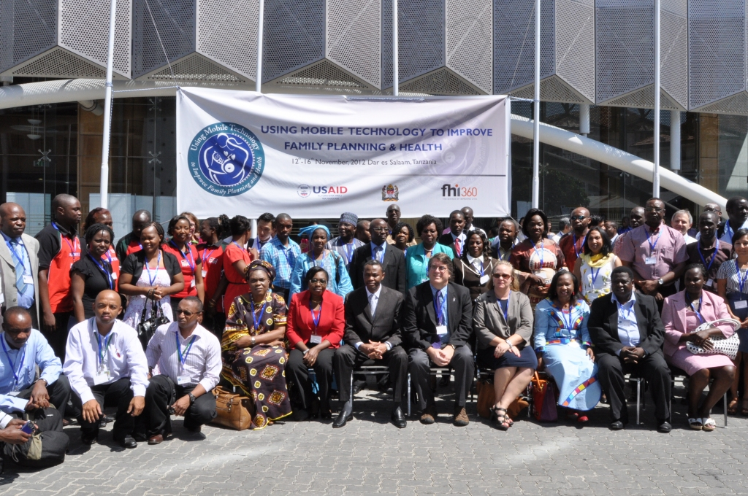

**Dar es Salaam, Tanzania**

**November 12-16, 2012**

 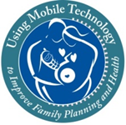 

**Acknowledgements**

The meeting on Using Mobile Technology to Improve Family Planning and Health Programs was hosted by the Ministry of Health and Social Welfare of Tanzania and USAID/Tanzania.   It was organized and driven by the 15 country teams who made remarkable efforts towards its success through extensive preparation and exchange of experiences at the meeting. The United States Agency for International Development’s Bureau for Global Health/Office of Population and Reproductive Health, the Bureau for Africa, the Regional mission in East Africa, USAID/Tanzania and FHI 360 provided the technical and logistical support to the country teams.

This report was prepared by Kaitlyn Patierno (USAID/AFR) and Gwen Morgan (MSH/ASH Project), with extensive input from Ishrat Husain (USAID/AFR) and Margaret D’Adamo (USAID/GH), and additional input from the organizing committee and meeting participants. For more information, please contact:

Kaitlyn Patierno Margaret D’Adamo

USAID/Bureau for Africa USAID/Bureau for Global Health

[kpatierno@usaid.gov](mailto:kpatierno@usaid.gov) [mdadamo@usaid.gov](mailto:mdadamo@usaid.gov)

202-712-1542 202-712-4301

**Introduction**   
This report documents the lessons learned from the regional meeting on “Using Mobile Technology to Improve Family Planning and Health Programs” held in Dar es Salaam, Tanzania from November 12-16, 2012.  The meeting was sponsored by the Bureau for Africa’s (AFR) Office of Sustainable Development and the Bureau for Global Health’s (GH) Office of Population and Reproductive Health of the United States Agency for International Development (USAID), USAID/East Africa and USAID/Tanzania.  It brought together country teams comprising representatives from governmental and non-governmental organizations, the private sector and civil society from 13 countries and two regional programs. This was the third in a series of meetings organized by the country teams to share experiences and ideas for improving family planning programs.   The country teams selected the topic of mobile technology as mobile phone penetration has increased rapidly in Sub-Saharan Africa; proving to be a game-changing technology for development.     
  
In addition to panel discussions, the teams organized a gallery walk for interactive demonstrations of the technologies they have integrated into their health programming.  The meeting also featured roundtable discussions with the private sector and with donors and site visits to observe mHealth applications in action.  As in the past, the organization of the meeting was led by the country teams, involving preparation and participation for months in advance.  The teams made the presentations and chaired the sessions. The participants awarded the country teams for outstanding efforts over the course of the meeting.   
  
This report (a) highlights the current use of mobile technology for health and the lessons for scaling up; (b) describes the visions and ideas of the country teams for future actions; (c) defines key takeaways from the private sector and donor contributions at the meeting.   
  
**Lessons Learned for Implementing Effective mHealth Programs at Scale**

**A.**      **Current Use of Mobile Technology in Family Planning and Health Programs**  
Within the field of mHealth, technology is rapidly evolving and programs are applying creative solutions in order to reduce program costs and strengthen service outreach. For the purposes of the meeting, the organizing committee divided the mHealth programs into seven categories: service delivery, logistics, management, communications, manpower (especially training), financing and monitoring and evaluation (M&E).   The current use of technology, as reported by the countries, varied considerably across these areas (see Annex 4 for definitions and summary of reported use).   Nearly all countries are using mobile technology to improve logistics, reporting and communications. Only half the countries reported using mobile devices for service delivery and still fewer for financing and monitoring and evaluation. No country reported the utilization of mobile technology for all seven program areas. While there is growing interest in and experimentation with mHealth programs, thoughtful monitoring and evaluation of processes and outcomes/impact must be encouraged in order to increase the evidence-base. The key lessons learned from the presentations and discussions are:

1. ***The intersection of mobile banking and mobile health offers much potential for effective interventions and innovation.*** Mobile money is a relatively new service internationally, first launched in Kenya about five years ago.   Three countries reported using mobile money to improve program management and reduce barriers to services.  Mobile money services are being used to reimburse private sector providers for services (Marie Stopes, Madagascar), to provide a way for families to save and pay for emergency health care services (Changamka, Kenya), to cover the costs of travel to health care facilities (Comprehensive Community Based Rehabilitation (CCBRT) in Tanzania), and to cover expenses for community health works (CHWs) doing home-based care for people living with HIV/AIDS (Pathfinder International, Tanzania).   These creative applications are leading the way for what can be accomplished by combining mobile money and health programming. The ability of countries to capitalize on mobile money services depends on the availability of these services in the country by the private sector. Making these services available and affordable is the first important step.
2. ***Mobile phone use focused on communities, and designed with the end user in mind, can dramatically improve the health system.***   Collaboration with end-users, such as health facility staff, CHWs or community leaders, can inform program design, thereby improving implementation in the local context.  The model of co-creation for developing mobile health technology, presented by the Consortium for Affordable Medical Technology (CAMTech), brings together the commercial private sector, innovators and end users to develop new technologies suitable to their needs. CAMTech has established co-creation labs in India and Uganda. In Madagascar, the NGO Human Network International (HNI) developed a simple, cloud based, do-it-yourself data communication service to collect real time data and share information with target groups through existing channels. Developed with the local context in mind, the platform uses simple survey forms, requires no local installation or maintenance and can operate through Smart Phones, the internet, or SMS. Nigeria’s Mobile Application Data Exchange (MADEX) incorporates an SMS-based data collection platform used to send monthly reports by midwives.  MADEX is designed for less technologically savvy users; the send button is the only action midwives must take in forwarding data to the central server.  Ethiopia developed a pilot to aid Health Extension Workers to use a cell phone to report their service statistics in real time rather than completing paper reports each month.  Econet, a telecommunications company in Burundi, developed a solar charging panel for mobile phones which can be used by CHWs in remote areas without electricity. These tools were designed in partnership with the end-users.
3. ***Commodity stock-outs in both the private and public sectors can be reduced notably through mobile phone reporting and ordering.*** Most countries reported using mobile technology to strengthen their logistics systems.   The Contraceptives Stock-Out Early Warning System, presented by the West Africa team and nominated by the participants as one of the best models, operates through an online system that collects data on national stock levels of contraceptives.  Countries can report data and revise reports directly online or submit reports offline if the internet system is not reliable.  In the private sector, the CHASS-SMT project in Mozambique provided technical assistance and ongoing training to pharmacy personnel aimed at improving stock control for medicines, distribution of ARVs and essential drug kits.
4. ***Creating an enabling environment for mobile health programs, including coordination of interoperable services, and development of national strategies and implementation plans, may lead to substantial improvements in health outcomes.*** A few countries are leading the way in creating an enabling environment for mHealth programs to flourish. In Tanzania, the Government led stakeholders in developing policies, guidelines, and strategies around eHealth/mHealth designed to increase interoperability and the potential for scale up.   It has also designated a national HMIS database (into which all data must be integrated). Kenya established a committed mHealth technical working group (TWG), led by the Division of Reproductive Health, to build on existing national commitment to creating an enabling environment for technology use. The TWG meets on a quarterly basis and has developed a Terms of Reference (TOR) to guide all partners, harmonize key communication messages for dissemination, and to avoid duplication of services.  Kenya is also investing in infrastructure to improve bandwidth and is increasing the number of licensed internet service providers to encourage competition and reduce costs.    In Rwanda a national TWG on Information and Communications Technology (ICT) exists, including stakeholders from the Government (including staff from regulatory agencies), telecommunication companies, implementers and donors, and liaises with a separate TWG on reproductive health.

1. ***Mobile technology has tremendous creative potential to impact and energize programming with youth, especially through multichannel approaches.***  The participants identified several particularly innovative models for reaching young people. In Madagascar, Orange organizes interactive contests to encourage young people to participate in developing health messages relevant to their peers.  In Tanzania, Kenya, and Rwanda, youth can call a national service like m4RH for information on FP/RH, HIV and youth friendly services.   C-word, a USAID-funded project implemented by Population Services International (PSI), uses a multi-channel approach to disseminate sexual and reproductive health information to youth through online media that can also be accessed through a mobile phone.
2. ***Inter-sectoral collaboration is a promising approach for more comprehensive and innovative health programming.***   Tanzania’ developed disease surveillance mHealth tools and databases linked to databases on weather, livestock, water and sanitation, and even tourism can lead to innovative and comprehensive programming that reaches a broader audience and may be more sustainable, as well as improve disease control.
3. ***Increased evaluation of programs and pilots to contribute to evidence on the efficacy and efficiency of mHealth projects is needed.*** More data is needed to inform policy and decision-making about when and how to invest in mHealth.  Santénet2, one of USAID/Madagascar’s largest programs led by the Research Triangle Institute (RTI), aims to expand demand for and use of health services by communities.   It conducted an assessment to determine the impact of its interventions after one of its partners, Marie Stopes International, observed an increase in family planning service uptake following on-line provider training and community mobilization activities.   The results of the assessment indicated that there was no increase in uptake following mass media interventions, while an increase did follow the phone-based provider training.  This enabled the program to shift some of its resources to interventions like training, which had demonstrated results. Tanzania and Kenya piloted m4RHto evaluate the feasibility and impact of providing family planning information via mobile phones. Evaluation of the pilot demonstrated a diverse range of users, including men and youth, and a positive impact on family planning knowledge and use. The governments of Kenya and Tanzania are committed scaling up, pending funding availability.
4. ***Mobile technology can help countries overcome human resource constraints by providing cost efficient approaches to supervision and continuous training.*** Over half of the participating countries reported using mobile technology to address manpower challenges. Uganda is piloting continuous capacity building for private providers via Skype. The private partners provide the airtime, but the system allows for continuous updates and education for providers, saves on operational costs for management, and reaches previously unreached private practitioners. Malawi has established an SMS platform for facility based nurses to strengthen the capacity of CHWs through simple question and answer surveys.  CommCare, a mobile-phone based application designed to assist CHWs in managing household visits, collect and report data, and monitor community health programs, was piloted in Tanzania by Pathfinder International and is now being scaled up. In 2011, Dimagi launched a cloud-based platform to deploy CommCare globally, providing easy access to data.
5. ***Adoption and uptake of innovative practices can be encouraged by providing a forum for idea exchange around innovation.***  In Tanzania, partners engage in an initiative called Mobile Monday, bringing together innovators in mobile technology.  Mobile Monday is an open platform of mobile industry visionaries, developers and influential individuals fostering brand-neutral cooperation and cross-border business opportunities through live networking events to demonstrate products, share ideas, and discuss trends from both local and global markets.
6. ***The private sector is a critical partner for taking mHealth programs to scale.*** The challenges and lessons learned for scale up are discussed in greater detail below, but many projects operating at scale do so in partnership with the private sector. In Kenya, World Vision led a partnership brokering process to bring together the largest telecommunications provider (Safaricom), NGOs and the government in order to scale up evidence-based mHealth programs. KimMNCHip/Safaricom provides integrated mobile maternal, newborn and child health information through Community Health Workers (CHWs).   Safaricom is working with MPESA (Kenya’s mobile money platform) to generate affordable business models, including development of a business case for mHealth solutions for all CHWs.

**B. Taking mHealth to Scale in Africa**  
While there are many innovative mHealth pilots around the continent, relatively few programs are operating at scale.   It is critical to evaluate such programs to determine their impact on health outcomes and cost effectiveness as compared to other alternatives. Many mHealth projects have been brought to scale through partnerships with private telecommunications companies.  These companies have a business interest in applications with broad appeal that will reach a large audience. Programs operating at scale presented at the meeting fell under three broad categories:

1. ***Communications:*** There are several large Social and Behavior Change Communications (SBCC) or tele-counseling programs operating through national telecommunications providers. In the DRC, “Ligne Verte” was the first hotline of its kind in the nation and was scaled up in 2005. Angola recently launched a national SMS program designed to educate mothers about maternal and child health issues. Mozambique’s Hello Life Project, a mass media campaign using TV and radio spots with a free hotline the audience can access with questions related to HIV/AIDS, aims to mobilize demand for testing and treatment and currently reaches 370,000 people.   Tanzania recently launched *Jiamini*, a national family planning campaign using the SMS platform m4RH (developed with MOHSW, FHI360, and partners) to provide a free, opt-in, interactive platform, where users can get information about FP methods and clinic locations.  The service is promoted using radio, TV and magazine advertisements.  The project has seen a 30% increase in queries and a 23% increase in unique users from the 10-month pilot period.
2. ***Logistics:*** Both Kenya and Tanzania are operating national electronic commodity stock control systems set up to function in multiple or all districts of a country.  *Tupange*, a Gates-funded reproductive health (RH) initiative in urban areas, uses mobile technology to track family planning commodity stock status and to disseminate information on family planning and reproductive health in 99 facilities in five cities across Kenya.   In Tanzania, JSI/Deliver designed ILSGateway, a mobile system used at the lowest level health facilities to allow real-time data on existing stock levels of crucial medicines.  Health facility personnel use personal cell phones to send logistics data via SMS to a toll-free number on a weekly basis, reducing program costs. This data is then transmitted to a website that analyzes and displays the information.
3. ***Service Outreach:*** Several countries are scaling up mHealth projects that seek to improve access to and quality of health services at the community level. The Government of Rwanda uses mobile technology to register and track all pregnant women in Rwanda.  Since the launch of the initiative, the number of facility-based births has increased from 70% to 84% and the government receives monthly reports from health workers across the country.  In Guinea, health workers are using mobile phones to refer patients for family planning services or when danger signs are observed in pregnant women or ill children. In Kenya, KimMNCHip/Safaricom provides integrated mobile services including an SMS/voice platform for BCC, mobile money services to deliver vouchers to pregnant women for clinics of their choice, and support for CHWs to provide the continuum of care.   In some cases private wireless telecommunication providers are willing to provide free or low cost airtime in order to increase “stickiness” (i.e., brand loyalty) and keep existing clients from switching to a competing provider.  In Madagascar, Airtel supports Human Network International’s (HNI) 3-2-1 free call-in service designed to improve access to information and referral on a range of topics, including health.

**Key considerations for Scaling up Mobile Technology**

mHealth implementers need to identify contextual factors and program elements necessary to successfully scale up mHealth projects.   Country team representatives identified several key factors for consideration when designing mHealth programs for scale:

* ***Careful assessment of pilots, including cost considerations*:** Scalability and sustainability factors include ensuring hardware and software chosen for the pilot can be used on a broader scale, involving all key stakeholders in design and implementation (including government, end-users and private sectors as applicable), aligning with national policies and strategies related to the health area and to mHealth, assessing cost, developing a long-term funding plan and measuring the impact of the intervention.
* ***Interface between the government/national authorities and local communities*:**  Local stakeholders, particularly community and traditional leaders, CHWs and local populations, should be engaged in the development and roll out of mHealth solutions.
* ***Clearly defined objectives and outcomes****:* Objectives of technology use must be clearly defined and target outcomes should both be in sync with local health priorities and serve the goals of the national health system.  The integration of mHealth into a national system will promote the long-term sustainability of mHealth projects.  This is particularly critical for HMIS projects.
* ***Engagement of strategic industry partners and leveraging resources*:** Such partnerships (ex. mobile network operators and technology companies) can provide a forum for sharing technical lessons learned and core competencies and resources.  The private sector is a critical partner in scaling up mobile technology, and improved understanding of the functioning of the private for profit sector will generate increased opportunities for partnerships. Furthermore, many countries now have burgeoning local technology sectors interested in social entrepreneurship which can also be leveraged for mHealth programs.
* ***Strengthening public sector capacity in mHealth*:** The establishment of a cross-cutting ministerial taskforce for mobile technology, including key private sector stakeholders such as the major telecommunications companies, will create the leadership necessary to bring evidence-based mHealth programs to scale.
* ***Utilization of technology as a tool for health system improvement and not standalone effort*:** mHealth approaches seem to work most effectively when they are a complementary tool used as part of a holistic program, not as a standalone intervention. The goal should be to collaborate to leverage existing efforts rather than run parallel solutions and duplicate efforts.

**Vision and Action Plans: Next Steps for Advancing the mHealth Agenda**  
On the final day of the meeting each of the country teams developed a vision (see Annex X) for expanding the integration of mobile technology into their health programming and identified actions to undertake in the next year in order to realize their vision. The actions identified by the teams are:

1. **Advocacy:** All countries identified advocacy as an important next step to generate country commitment following the meeting.   Many countries propose to do this through the establishment of a national task force.
2. **National Strategy:**  At present, only Kenya and Tanzania have developed a national eHealth strategy.  These countries have also been extremely successful in moving their e- and mHealth agendas forward.  Burundi, Malawi and Nigeria have proposed to develop a national strategy.
3. **Public-private partnership:**  The country teams from DRC, Kenya, Madagascar and Nigeria included strong participation from private sector companies.   These countries plan to expand and strengthen engagement with the private sector by partnering with mobile telecommunications companies to scale up mHealth programs.
4. **Evaluation and Assessments:** Many participants stressed the need for assessments of the current mHealth landscape in their country and evaluations of mHealth projects to determine impact, scalability and sustainability.  Burundi, Malawi and Nigeria plan to conduct an assessment of the current status of use of technology in order to move forward in a systematic manner. Kenya, Madagascar and Tanzania proposed evaluations of the current programs.
5. **Scale up:** Madagascar, Rwanda and Tanzania are continuing to scale up successful programs, but are seeking additional resources in order to do so.
6. **Costing:** Malawi and Rwanda propose to undertake a costing exercise of expanding mobile technology use to strengthen their health programming.

**Resources for the Vision: Private sector and Donor Perspectives and Priorities**

1. **Highlights of the Private Sector Roundtable**

The meeting featured a highly interactive private sector roundtable including representatives of Airtel, Airtel Foundation, Econet, Telma, Telma Foundation, Vodacom, and Vodafone Foundation. The lively dialogue between the panel and audience provided a great deal of insight into the challenges, opportunities and key approaches to productive public-private partnerships. Highlights of the Q&A are below:

***How can the public sector appeal to the private sector as a partner?***

The public and private sectors have areas of comparative advantage that can generate benefits to partnering.  The panel representatives identified longer time frame and continuity (which generate stability), risk management and credibility as key public sector advantages. Where they exist, these features can attract the private sector to partner with the public sector.

***How can the public and NGO sector generate interest in partnerships for the public good?***

Private companies are already investing a great deal in communities and are also beholden to their shareholders to earn profits.  Public health stakeholders can approach the company foundation side and ensure their proposal aligns with the priorities of the foundation. Sustainable engagement of the corporate sector in health for low-income and vulnerable populations should ideally be based on both business incentives and social impact goals. For example, Human Network International (HNI) was able to create a business case for Airtel’s partnership in the 3-2-1 program described above. Airtel provided some free airtime as the application generates customer loyalty (“stickiness”).

***How should the public and NGO sectors approach the private sector?***

Stakeholders should first determine common values then approach the private sector with a well-developed plan which aligns with the interests or expertise of the company. Private companies can provide insight on their own potential contributions to the plan. Activities intended to operate at scale, are within the interest of the private sector partner and have a business incentive will have greater appeal to the private sector.

***How can stakeholders encourage competing companies to cooperate around health initiatives?***

When the public sector approaches the private sector to partner on a health initiative, they often try to bring numerous private partners to the table. It may be more productive to assign separate roles to competing partners; if the initiative is a marketing initiative, companies will not want to share it. Stakeholder should also consider if more partners actually adds value; if it does, the reason for having multiple partners at the table must be clearly articulated. If multiple companies are partnering, risk must be distributed equally across all companies. The involvement or leadership of the government can be helpful when multiple partners need to be involved.

***How can we improve interoperability for public health applications?***

In most countries there is a regulatory authority taxing companies for communication across systems. The public sector could take the lead in advocating for improved interoperability.

1. **Highlights of the Donor Roundtable**

The meeting concluded with a roundtable to discuss key donor priorities in future mHealth efforts. The donors represented at the meeting articulated the following areas of interest:

* **United States Agency for International Development (headquarters)**: USAID has an mHealth coordinator in the Bureau for Global Health. The Office of Population and Reproductive Health has drafted a brief on evidence-based mHealth applications, which will be published as part of its High Impact Practices series. USAID is also supporting an mHealth Working Group which meets regularly, hosts a listserv that includes over 1,000 members and has developed a website and toolkit (mhealthworkinggroup.org). The Toolkit provides information on mHealth programs and pilots, including evaluations and research around which programs are working. USAID is also developing an mHealth 101 eLearning course to be hosted on its Global Health eLearning platform ([www.globalhealthlearning.org](http://www.globalhealthlearning.org)) as well as an mHealth implementation Guide.
* **USAID/East Africa**: USAID/East Africa is taking the lead in developing the capacity of regional institutions to help countries expand the use of mobile technology. The ultimate objective is to help institutions and countries make the best use of growing economic power and attain sustainability in health programs. In partnership with USAID/WA, the office proposed to develop a regional mHealth network supported by key regional institutions.
* **International Finance Corporation**: The IFC is interested in working with countries to develop partnerships with the private sector in mHealth and to help governments generate an environment that is conducive to businesses working in developing mobile technology infrastructure and applications. The IFC provided assistance to the Kenyan Government to develop an eHealth strategy. It now plans to work with USAID/East Africa to strengthen the capacity of the East Africa Community to promote the use of mobile technology.
* **The World Bank**: The World Bank is interested in taking evidence-based pilots to scale. These activities can be part of existing Bank projects or those in the lending program.

**Next Steps**

USAID/W and the Regional Missions in East and West Africa are working to support countries’ efforts to expand the use of mobile technology. These include (a) identifying opportunities for expanding engagement with the private sector; (b) leveraging donor resources; (c) facilitating continued exchange of ideas and best practices; (d) providing technical assistance and developing south to south cooperation; and (e) preparing to review progress in conjunction with the International Family Planning Conference in November 2013. The following activities have been undertaken thus far:

* ***Leveraging the private sector:*** USAID/W is exploring innovative financing mechanisms to help countries bring effective mHealth programs to scale. One promising avenue is the use of the Development Credit Authority (DCA) mechanism to provide guarantees to the banking sector for investments in health activities. The banking sector has significant resources that can be leveraged for scaling up mobile technology. The DCA office at USAID is ready to provide assistance to Missions to determine opportunities and generate proposals. In addition, USAD/W is exploring the possibility of partnering with social investment organizations such as Acumen Fund. Acumen could potentially provide technical assistance and funding to eHealth entrepreneurs based on the existing model of the Global and Regional Fellows programs.
* ***Mobilization of donor funding***: UASID/W will brief the donors that provided funding for Family Planning 2020 on the outcome of the Dar meeting and explore their interest in funding country level activities and/or providing technical assistance as requested.
* ***Knowledge sharing***: USAID/W presented on the proceedings and outcomes of the meeting at the mHealth Summit in Washington DC in December 2012. The regional missions in East and West Africa are exploring the development of regional networks for continued exchange of experiences on eHealth. In the interim, a listserv has been developed to exchange information among meeting participants. USAID/W has contacted Missions to discuss progress and support needed from Washington.
* ***Technical assistance and study tours***: USAID/W has been in contact with the Missions to follow up on technical assistance and study tour needs identified by the country teams. AFR and PRH are collaborating with partners to address these requests. Thus far, USAID is working with Burundi to arrange a study tour for senior Ministry officials to Madagascar, exploring technical assistance for costing with Rwanda and following up on support for strategy development in several other countries.
* ***Follow Up Meeting in Addis Ababa in November 2013***: USAID/W is exploring the opportunity to organize a one or two day meeting prior to the International Family Planning Conference to review and exchange information on progress made by the countries since the meeting in Dar es Salaam. This will also provide an opportunity to identify the topic for the next meeting.

**Annex 1 – Meeting Objectives, Process and Agenda**

This meeting will share promising practices for family planning, with respect to:

1. Adopting, using and scaling up mobile technologies that contribute to improved management, better training, increased demand for and improved delivery of family planning and health services.
2. Adopting broad multi-sectoral programming in collaboration with the private sector and relevant ministries and organizations to benefit from synergies at the regional, national and community levels.

The expected outcome of the meeting is for country teams to benefit from:

* State of the art information on the way mobile technology is being used or could be used to improve the implementation of family planning and health programs;
* Examples of how mobile technology can increase efficiencies in the use of resources, enhancing value for money;
* Practical aspects and approaches for the utilization of mobile technology, including innovative programming ideas, addressing obstacles, and expanding engagement with the private sector;
* Donors’ perspective and opportunities for enhanced partnership.

Processes: This is the third in a series of meetings on family planning, following those in Kigali in 2010 and Nairobi in 2011. These meetings have provided platforms to country teams to exchange information and ideas among themselves on cutting edge topics of their choice. The meeting is country driven and country led, featuring presentations and discussions on country experiences. The teams participate in organizing and conducting the meeting. Country teams comprise governmental and non-governmental organizations, the private sector, and, in some cases, community and youth representatives.

Country groupings: The country teams are divided into four groups for presentations and panel discussion. The groups are based on language and progress on the integration of mobile technology into programs and/or strength of the family planning program.

Session Chairs: Senior government representatives from each country team will chair the sessions. Country teams have been requested to submit the name of the chair from their country. The agenda will be revised accordingly.

Gallery walk: Each country team and private sector representatives will set up a booth to display their programs and/or the innovative products. There will be interactive sessions at each booth and participants will rotate. The gallery walk will remain up until Wednesday.

Private sector roundtable: Since there will be significant private sector representation (from country teams and external), a private sector roundtable is being organized to discuss ways to expand private sector engagement in various countries.

Donor Roundtable: At this roundtable, donors attending the meeting will have an opportunity to comment on the ideas emerging from the meeting and their interests in supporting them.

|  |  |
| --- | --- |
| **Conference Agenda**  **Bank of Tanzania** | |
| **Monday, 12 November 2012**  **Where We Are: State of the Art in Mobile Technology for Health; Products and Programming** | |
| 8:00-8:30 | Registration and Coffee |
| 8:30-9:10 | **Welcome Session**  *Chair:* Dr.Getachew Tefera, RCQHC  **Welcome from the Organizers**  *Timothy Manchester, USAID, on behalf of the Conference Organizing Committee (5 min)*  **Greetings from USAID**  *Robert Cunnane, Mission Director (5 min)*  **Greetings from the Donors**  *World Bank Group, International Finance Corporation, UNFPA (15 min)*  **Official Opening**  *Honorable Dr. Hussein Mwinyi, Minister of Health, Tanzania (15 min)* |
| 9:10-10:00 | **Getting Started**  *Chair: Ladiama Serme, Ministry of Health, Burkina Faso*  **Opening Remarks**  *Scott Radloff and Ishrat Husain, USAID (30 min)*  **Facilitators’ Comments**  *Nelson Gitonga and Peggy D’Adamo (20 min)* |
| 10:00-10:30 | Group Photo and Coffee |
| 10:30-12:30 | **Reaching for the Sky: State of the Art and What’s on the Horizon**  *Chair: Dr. Anicet Nzabonimpa, Ministry of Health, Rwanda*  **The Mobile Connection to MDG 5**  *Christine Lasway, FHI 360 (15 min)*  **Co-Creation: Avoiding the Pitfalls in Technology Development for Health**  *Kris Olson, Medical Director, CAMTech, Massachusetts General Hospital (15 min)*  **Putting mHealth to Work- the Hype and the Potential; Where to Invest Development Assistance, Partnership, and How to Work with the Industry**  *Andrew Dunnett, Director, Vodafone Foundation, Vodafone Group Services Limited (30 min)*  **Discussion** (1 hour) |
| 12:30-13:30 | Networking Lunch |
| 13:30-15:00 | **International Support for Reaching the Horizon; Policies and Strategies**  *Chairs: Dr. Dionese Nzigyimana, Ministry of Health, Burundi; Rose Madinda, Ministry of Health, Tanzania*  **Donor Perspectives**  *Adam Slote, USAID mHealth Coordinator, USAID/Washington; Sandhya Rao, Senior Advisor for Private Sector Partnerships, USAID/Washington; Meera Shekar, Lead Health Specialist, The World Bank Group; Bernard Olayo, Policy Officer, International Finance Corporation; Sennen Hounton, UNFPA (10 min each)*  **Discussion** (30 min) |
| 15:00-17:30 | **Gallery Walk: Walking Through Time – Technology for Now and the Future**  During the gallery walk the country teams will demonstrate their work and wares in interactive booth sessions. |
| **Tuesday, 13 November 2012**  **Reflecting and Sharing Experiences** | |
| 8:00-8:30 | Morning News |
| 8:30-10:00 | **Panel: Country Presentations and Discussion**  *Chair: Dr. Madina Rachide, Ministry of Health, Guinea*  Group 1: Rwanda, Democratic Republic of the Congo, Madagascar (7 min each)  Discussion (1 hour) |
| 10:00-10:30 | Coffee |
| 10:30-12:00 | **Panel: Country Presentation and Discussion**  *Chair: Gladys Someren, Ministry of Health, Kenya*  Group 2: Ethiopia, Angola, Mozambique, Nigeria (7 min each)  Discussion (1 hour) |
| 12:00-13:00 | Networking Lunch |
| 13:00-15:00 | **Spotlight on Tanzania**  *Chairs- Kassahun Sime Geleta, Ministry of Health, Ethiopia; Timothy Manchester, USAID/Tanzania*  **Segment I- Cross-Cutting Presentations**  **Overview of the Mobile Technology Ecosystem in Tanzania**  (10 min)  *Freddie Manento, PushMobile*  **Leadership and Coordination in Strengthening mHealth** (10 min)  *Marcus Mzeru, MOHSW*  **Partnership and Collaboration Between mHealth Programs** (10 min)  *Sarah Emerson, CDC Foundation, Tanzania*  **Promotion of mHealth Innovations** (10  min)  *Jennifer Orkis, Johns Hopkins University, Capacity and Communications Project*  **Discussion** (20 minutes)  **Segment II- Highlights of mHealth Innovations**  **Point of Care Support for Health Workers** (8 min)  *Julia Ruben, D-Tree International*  **Supply Chain Management** (8 min)  *Noela Kisoka, John Snow International*  **Health Promotion and Education** (8 min)  *Peter Masika, TAYOA*  **Data Collection and Record-keeping** (8 min)  *Nassor Kikumbih, EngenderHealth*  **Health Financing** (8 min)  Tom Vanneste, CCBRT    **Discussion** (20 mi nutes) |
| 15:00-15:30 | Coffee Break |
| 15:30-18:00 | **Tanzania Technology Demonstration**  mHealth programs in the host country of Tanzania provide presentations, discussion and hands-on demonstrations. |
| **Wednesday, 14 November 2012**  **Continued Reflecting and How to Engage New Partners** | |
| 8:00-8:15 | Morning News |
| 8:15-9:30 | **Panel: Country Presentations and Discussion**  *Chair: Dr. Fidele Mbadu, Ministry of Health, Democratic Republic of the Congo*  Group 3: Guinea, Burundi, West Africa (7 min each)  Discussion: (1 hour) |
| 9:30-10:00 | Coffee |
| 10:00-11:30 | **Panel: Country Presentation and Discussion**  *Chair: Nneka Oteka, Ministry of Health, Nigeria*  Group 4: Kenya, Uganda, East Africa, Malawi (7 min each)  Discussion (1 hour) |
| 11:30-12:00 | **Expert Panel Discussion: Responses to Country Presentations**  *Chair: Jean Mwalabu, Ministry of Health, Malawi*  **Expert Panel**  *Sennon Hounton, UNFPA; Beatrice Sing-Mallya, Airtel; Bernard Olayo, IFC* |
| 12:00-13:00 | Networking Lunch |
| 13:00-15:00 | **Private Sector Roundtable: Leapfrogging into the Future for Scale-up and Introduction of Mobile Technologies**  *Chairs- Gene Peuse, USAID/Tanzania; Sandhya Rao, USAID/Washington*  What can governments and donors do to be better partners with the private sector? How does the private sector define a successful PPP? How can the private sector support the ideas and actions coming out of the meeting?  *Beatrice Singano-Mallya, Airtel, Tanzania; Lee Wells, Vodafone, Tanzania; Viviane Mulenda, Vodacom, DRC; Oluwasina Dada, Airtel, Nigeria; Olivier Hakizimana, ECONET, Burundi; Krishnamurthy Gopalakrishnan, World Health Partners* |
| 15:00-15:30 | Coffee |
| 15:30-17:00 | **Donor Roundtable: Seizing the Moment and Accelerating Introduction and Scale-Up of Technology in FP/MCH Programs**  *Chair- Dr. Filomena Wilson, Ministry of Health, Angola*  How can donors support the ideas and actions emerging from the meeting? What is the follow-up?  *IFC, The World Bank, Acumen, UNFPA, USAID* |
| 17:00-17:30 | Briefing on site visits |
| 18:00-19:00 | Spotlight on Madagascar  *David McAfee, Executive Director, Human Network International* |
| **Thursday, 15 November 2012**  **Technology in Practice: Site Visits** | |
| 8:00-16:00 | Teams participate in site visits in and around Dar es Salaam |
| 18:00-20:00 | Reception |
| **Friday, 16 November 2012**  **Creating and Realizing a Vision** | |
| 8:00-9:00 | Morning News: Sharing Feedback About Site Visits |
| 9:00-10:00 | **Open Space**  Participants can meet to discuss topics of their choice, which will be determined throughout the week. |
| 10:00-12:00 | **Creating a Vision and Identifying Actions for Realizing the Vision: Taking the Present to Scale and Reaching for the Horizon**  During this working session each country team will work individually to develop a vision and action plan, which will be presented in afternoon panel. Resource persons will be available. Coffee will be served during the session. Teams will work to address the following questions:  *What is the vision for utilizing technology and how will it be realized? How to partner with the private sector? How to mobilize funding to achieve the vision? What are the necessary policy and regulatory changes?? How to scale up successful programs? What are the cost considerations for scaling up?* |
| 12:00-13:00 | Networking Lunch |
| 13:00-15:00 | **Vision to Action – Report back**  *Chair- Robert Kolesar, USAID/Madagascar*  Four panels comprised of one representative from each country team will be interviewed about the vision, key actions, and timeline for action developed during the working session earlier in the day. The audience will have an opportunity to ask questions about aspects of country programs that are of interest. Country groupings will be the same as on the 1st and 2nd day. |
| 15:00-15:15 | Evaluation |
| 15:15-16:00 | **Closing**  **Summing it all up! What we heard, saw and leave with**  *Insights from Two Participants*  **Awards Ceremony**  *Scott Radloff, Director, Office of Population and Reproductive Health, USAID*  **Official Closing**  *Rose Madinda, Ministry of Health, Tanzania*  *Scott Radloff, Director, Office of Population and Reproductive Health, USAID* |

**Annex 2 – Participants**

|  |  |  |  |
| --- | --- | --- | --- |
| **Country** | **Surname** | **First name** | **Organization** |
| Angola | Tiounine | Mikhail | National Malaria Control Program |
| Angola | Guimardes | Gisele | USAID |
| Angola | Narine | Vishnu | UNFPA |
| Angola | Bonillia | Julio | JHPIEGO |
| Angola | Madeira | Miguel | CAJ (Youth Support Center) |
| Angola | Wilson | Filomena | MOH |
| Angola | Kruck | Jessika | PSI |
| Burundi | Ntunzwenayo | Charles | MOH/Muyunga Province Health District |
| Burundi | Ndereye | Juma | MOH, National RH Program |
| Burundi | Ndabagiye | Irene | MOH |
| Burundi | Gahungu | Népomucène | MOH/Kayanza Province Health District |
| Burundi | Hakizimana | Olivier | ECONET |
| Burundi | Nizigiyimana | Dionise | MOH |
| Burundi | Inamahoro | Chantal | Pathfinder |
| Burundi | Ntakarutimana | Donatien | USAID |
| DRC | Kasongo | Gaby | ASF/PSI |
| DRC | Mbo | Marie Louise | MOH |
| DRC | Mbadu | Fidele | MOH |
| DRC | Mulenda | Viviane | Vodacom |
| DRC | Mukaba | Thibaut | USAID |
| DRC | Binanga | Arsene | IRH |
| DRC | Ntoya | Ferdinand | FHI 360 |
| DRC | Mputu | Jean Baptiste | MSH |
| East Africa | Onyango | Sarah | USAID/EA |
| East Africa | Henn | Julia | USAID |
| East Africa | Tefera | Getachew | RCQHC |
| East Africa | Odiyo | Odongo | USAID |
| East Africa | Marsden | Solomon | FHI 360 |
| Ethiopia | Bogale | Tariku Nigatu | IFHP |
| Ethiopia | Abdu | Ebrahim | DKT |
| Ethiopia | Endota | Wondwossen Teka | FHI 360 |
| Ethiopia | Luelsegend | Henock | WB |
| Ethiopia | Bejiga | GEBREMARIAM | CHAI |
| Ethiopia | Esubalew | Sebsibe | FMOH |
| Ethiopia | Mahtsentu | Mebrahtu | FMOH |
| Ethiopia | Mengistu | Kifle | FMOH |
| Ethiopia | Okello | Francis | FHI 360 |
| Ethiopia | Sintayehu | Abebe Woldie | FMOH |
| Ethiopia | Kassahun | Sime Geleta | FMOH |
| Guinea | Cissé | Gassin | JHPIEGO |
| Guinea | Rachide | Madina | MOH |
| Guinea | Balde | Marouf | USAID |
| Kenya | Karuthiru | Jerusha | USAID |
| Kenya | Mbugua | Irene | World Vision |
| Kenya | Makai | Benjamin |  |
| Kenya | Magaria | Loice | FHI 360 |
| Kenya | Olawo | Alice | FHI 360 |
| Kenya | Muhati | Jacquie |  |
| Kenya | Macharia | Sheila | USAID |
| Kenya | Someren | Gladys | MOPHS |
| Kenya | Chemwolo | Benjamin | Ampact |
| Kenya | Kibutha | Annrose | LVCT |
| Kenya | Oyuga | Lenin | Pharm Access/Tupange |
| Kenya | Kubai | Edward | Marie Stopes Kenya |
| Kenya | Karimi | Susan | PSI Kenya |
| Kenya | Omyonga | Janet | JHPIEGO/Tupange |
| Kenya | Ling | Jocelyn | Acumen |
| Kenya | Karimi | Onesmus | PATH/AIDS Free Generation |
| Madagascar | Kolesar | Robert | USAID |
| Madagascar | Andrianansionona | Francia | Orange |
| Madagascar | RAHARINOSY | Gaelle | Telma |
| Madagascar | Rasoazanakolona | Hoby | PSI |
| Madagascar | Randrianjafy | Harivola | PSI |
| Madagascar | Ramanantsialonina | Andriantsoa | IFC |
| Madagascar | Rahaingonjatovo | Danielle | FONDATION TELMA |
| Madagascar | Ralijaona | Lova Avotra | JSI |
| Madagascar | Gourrand | Francois | Marie Stopes Madagascar |
| Madagascar | ANDRIANAIVO | Heritiana | Santenet2/RTI |
| Madagascar | Herilala | Andriamialy | JSI/CBIHP |
| Madagascar | Mcafee | David | HNI |
| Malawi | Msukwa | Chimwemwe | USAID |
| Malawi | Bakasa | Carol | USAID |
| Malawi | Bartlett | Premila | JHPIEGO |
| Malawi | Kapindula | Limbanazo | MSH |
| Malawi | Chipeta Khonje | Angela | Banja La Mtsogolo |
| Malawi | Tsirizani | Edith | Airtel |
| Malawi | Villanueva | Monica | USAID |
| Malawi | Mwalabu | Jean | MOH, RH Unit |
| Malawi | Mwalabu | Elias | JSI |
| Mozambique | Chuau | Inusso | MOH |
| Mozambique | Sigauque | Olga Antonio | MOH |
| Mozambique | Paunde | Odete | USAID |
| Nigeria | Oteka | Nneka |  |
| Nigeria | Oritseweyimi | Ogbe |  |
| Nigeria | Dada | Oluwasina |  |
| Nigeria | Azubuike | Paschal |  |
| Nigeria | Shobowale | Mofoluke | SHOPS |
| Nigeria | Uduh | Steve | NPHCDA |
| Nigeria | Ibraye | Tonte | White Ribbon Alliance |
| Nigeria | Jagha | Temple | SFH/ESMPIN |
| Nigeria | Maiwada | Abdullahi | USAID |
| Nigeria | Zainu | Kamilu | Pampaida Millennium Villages Project |
| Other Agency | Shekar | Meera | World Bank |
| Other Agency | Gopalakrishnan | Krishnamurthy | WHP |
| Other Agency | Maggwa | Baker | FHI 360 |
| Other Agency | Casillas | John | IFC/World Bank |
| Other Agency | Zan | Trinity | FHI 360 |
| Other Agency | Santorino | Data | CAMTech, Mbarara University |
| Other Agency | Siedner | Mark | CAMTech, Massachusetts General |
| Other Agency | Olson | Kris | CAMTech, Massachusetts General |
| Other Agency | McNabb | Marion | Pathfinder International |
| Other Agency | Hounton | Sennen | UNFPA |
| Other Agency | Feyisetan | Bamikale | E2A Project |
| Other Agency | Olayo | Bernard | IFC/World Bank Group |
| Other Agency | Gitonga | Nelson | Facilitator |
| Other Agency | De Buysscher | Rose | FHI 360 |
| Other Agency | Sharpey-Schafer | Kieran | Dimagi |
| Other Agency | Morgan | Gwendolyn | ASH Project |
| Rwanda | Nzeyimana | Anastase | FHI 360 |
| Rwanda | Nzabonimpa | Anicet | MOH |
| Rwanda | Uwayezu | Gilbert | MOH |
| Rwanda | Wesson | Jennifer | FHI 360 |
| Rwanda | Kagame | Eric | USAID |
| Rwanda | Ssenfuka | James | UNFPA |
| Rwanda | Mukakabanda | Suzanne | FHP |
| Rwanda | Uwantwali | Didier | Pivot Access |
| Tanzania | Manchester | Timothy | USAID |
| Tanzania | Lasway | Christine | FHI 360 |
| Tanzania | Wasira | Rose | MOH |
| Tanzania | Adinda | Rosemarie | MOH |
| Tanzania | Tayler | Liz | DfID |
| Tanzania | Rusibamayila | Neema |  |
| Tanzania | Peuse | Gene | USAID |
| Tanzania | Mzeru | Marcos | MoHSW |
| Tanzania | Marona | Cristin | Futures Group |
| Tanzania | Ruben | Julia | D-Tree |
| Tanzania | Semedo | Benny |  |
| Tanzania | Massoud |  |  |
| Tanzania | Lipingu | Chrisostom | JHPIEGO |
| Tanzania | Manento | Freddie | Push Mobile |
| Tanzania | Wu | Lushen | Bienmoyo Foundation |
| Tanzania | Dia | Ousmane | JSI |
| Tanzania | Chole | Michael |  |
| Tanzania | Hiza | Maulise | MOH |
| Tanzania | Kisoka | N | JSI |
| Tanzania | Matoyo | D | JSI |
| Tanzania | Nyaruse | Isabela | MOH |
| Tanzania | Mselle | Grace | APHFTA |
| Tanzania | Kudrati | Mustafa | Pathfinder |
| Tanzania | Kanowa | Peter | CSL |
| Tanzania | Ishengoma | Joyce | EngenderHealth |
| Tanzania | Njau | Judith | APHFTA |
| Tanzania | Cameron | Alisa | USAID |
| Tanzania | Frank | Elly |  |
| Tanzania | Musunga | Sammy | FHI 360 |
| Tanzania | Kahale | Singwa | FHI 360 |
| Tanzania | Ndakidemi | Elizabeth | FHI 360 |
| Tanzania | Murashani | Justin |  |
| Uganda | Tefera | Gefechew | Rcone |
| Uganda | Kimera | Richard | CAMTech, Mbarara University |
| Uganda | Katarikawe | Emily | Uganda Health Marketing Group |
| Uganda | Duworko | James | USAID |
| Uganda | Wamala | Patricia | FHI 360 |
| USAID | Radloff | Scott | USAID |
| USAID | Husain | Ishrat | USAID |
| USAID | D'Adamo | Peggy | USAID |
| USAID | Slote | Adam | USAID |
| USAID | Martin | Erika | USAID |
| USAID | Todd | Alex | USAID/GH/PRH |
| USAID | Rao | Sandhya | USAID/GH/HIDN |
| USAID | Hempstone | Hope | USAID/GH/PRH |
| USAID | Patierno | Kaitlyn | USAID/AFR |
| West Africa | Fossand | Karla | USAID WA |
| West Africa | Ludiama | Serme | MOH, Burkina Faso |
| West Africa | Damessi | Yawo | MOH, Togo |
| West Africa | Murphy | Maggie | DELIVER |

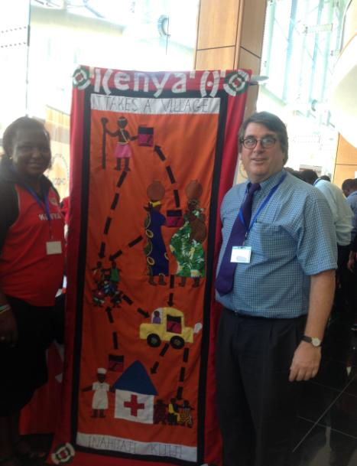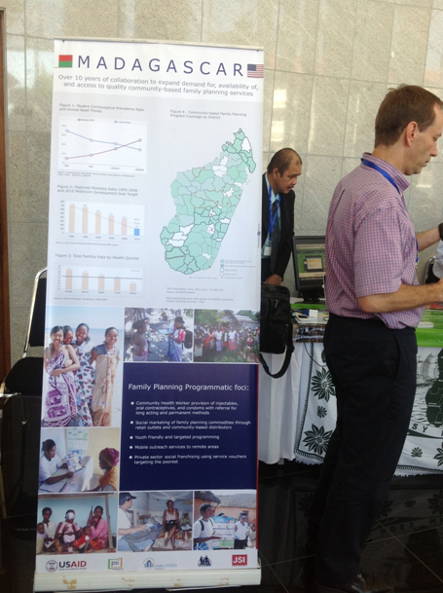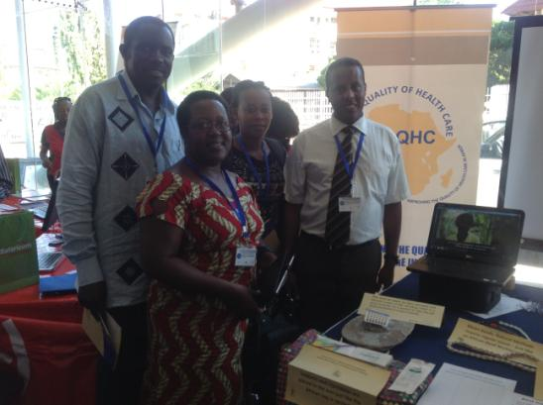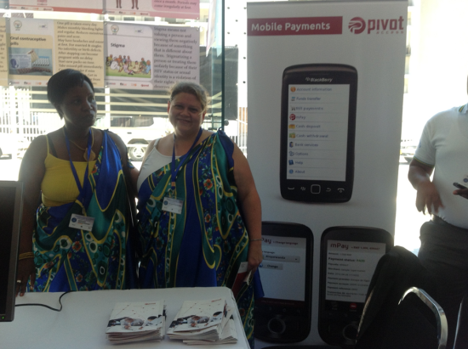**Annex 3 – Gallery Walk**

USAID/Kenya’s Jerusha Karuthiru and PRH Director Scott Radloff present Kenya’s “It Takes a Village” banner, showing the use of mobile technology at all levels of the health system.

David McAfee, HNI, demonstrates the cloud-based platform developed in Madagascar.

The East Africa team stands by their booth.

Rwanda’s country team presents in traditional garb.

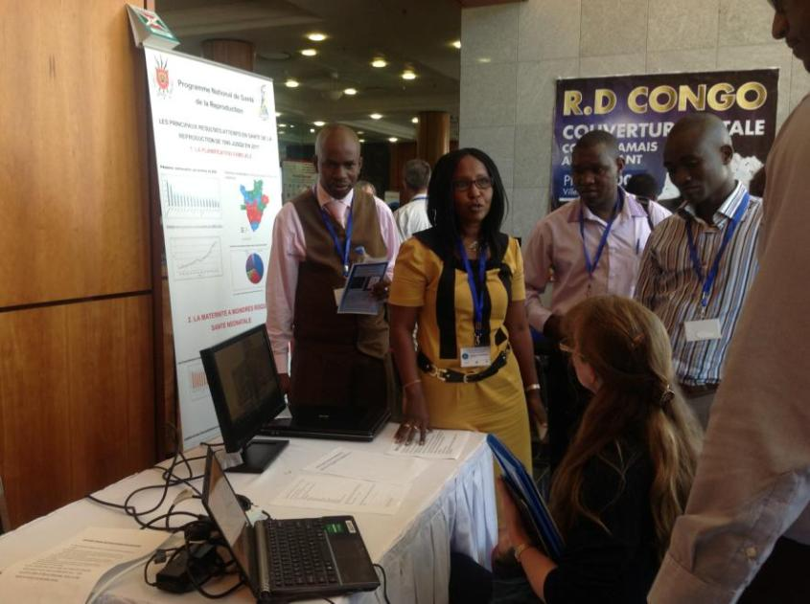

The Burundi team described their innovative mHealth programming to participants from other countries.

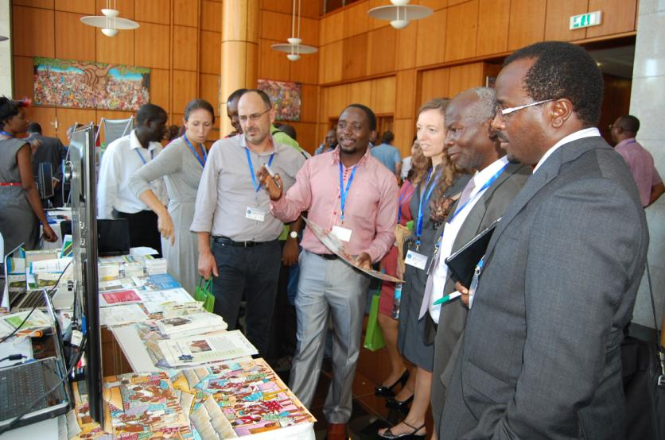

The Tanzania team answers questions about their programs during the gallery walk.

**Annex 4 – Current Use of Mobile Technology for Health Programs**

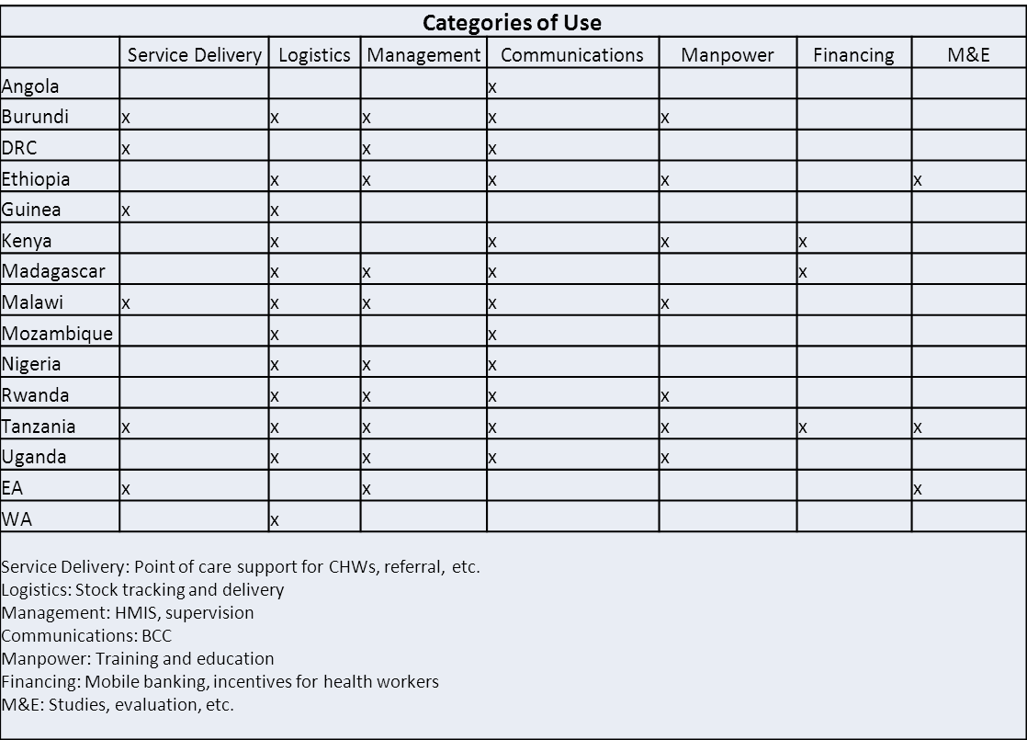

**Annex 5 – Vision Statements by the Country Teams**

**Angola**

Accelerate or increase the actual rate of health service use by integrating mobile and e-technology components into the National MNCH Communications Strategy.

**Burundi**

The partnerships and the coordination mechanisms for the use of Mhealth technologies are in place and enhance to the decision-making for the implementation of the Maternal, new born and child health in Burundi.

**DRC**

Intégration rationnelle de mHealth technologie dans le système national de sante pour: Améliorer la coordination, l’utilisation de service et la gestion des programmes.

**East Africa**

Scale-up innovative e/mHealth solutions to accelerate sustainable gains in health outcomes through networks of African innovators and leading institutions.

**Ethiopia**

To see an improved quality of health care services through the use of mobile technology.

**Guinea**

Amélioration de la performance du système de santé à travers l’introduction et la systématisation de l’utilisation des nouvelles technologies dans les programmes de santé.

**Kenya**

Healthy families enjoying positive health outcomes through innovative health initiatives.

**Madagascar**

Optimal utilization of innovative mobile technologies to promote maternal, child and youth health and family planning in Madagascar.

**Malawi**

A strong, vibrant and coordinated eHealth strategy and platform to improve MCH and RH programs in Malawi.

**Mozambique**

Strengthen the use of tools and methodologies based on innovative information for integrated health services particularly for family planning and health information systems

**Nigeria**

Using mobile technologies /ICT to improve access and provision of health care services, information and commodities in line with the Saving One Million Lives initiative of the Government of Nigeria.

**Rwanda**

To realize concrete improvements in the Rwanda Maternal Child Health (MCH) Program using mobile technologies.

**Tanzania**

Evidence-based, cost-effective mhealth solutions that are scalable, integrated, sustainable, efficient & adaptable to improve health outcomes.

**Uganda**

Use e- and mHealth to increase access and quality of health information and services.

**West Africa**

**Togo**

Utilisation de la telephonie mobile et d’internet pour prevenir les ruptures de stock des medicaments essentials (PF, paludisme, vaccins, VIH, TB).

**Burkina Faso**

Améliorer la gestion logistique des produits de la sante de la reproduction en utilisant la telephonie mobile au Burkina Faso.